**ProfileBook  
Capstone Project Report**

Submitted by: Venkatesh Modugumudi

Batch: WIPRO NGA-.Net Full Stack Angular -FY26 -C3

Instructor: Mr. Ramesh Nediyadath

Date: 7th September 2025

Table of Contents

Abstract 3

Introduction & Problem Statement 4

Problem Statement 4

Objectives 4

System Requirements & User Stories 5

User Stories 5

System Architecture 6

Frontend Design (Angular) 7

🔹 Admin Module 7

🔹 User Module 7

🔹 Core Files 7

🔹 Services 7

Backend Design (ASP.NET Core) 8

🔹 Controllers 8

🔹 Models 8

🔹 DTOs (Data Transfer Objects) 8

Database Design & ERD 9

Demo Plan & Screenshots: 15

Testing & Security 19

Security 20

Conclusion & Future Work 21

# Abstract

The ProfileBook project is a web-based application developed using ASP.NET Core for the backend and Angular for the frontend. The main objective of this system is to provide users with a secure platform to create, manage, and update their personal and professional profiles. It simplifies profile management by offering features such as user registration, authentication, role-based access, and profile editing.

The backend is responsible for handling business logic, authentication, and database communication, while the frontend ensures a responsive and user-friendly interface. Data is stored securely using a structured database, and security is enhanced through proper validation and access control.

This project demonstrates the integration of modern web technologies to build a scalable and efficient system. It not only helps users maintain their personal details in a structured way but also showcases best practices in full-stack development, including component-based design, RESTful APIs, and database-driven applications.

# Introduction & Problem Statement

ProfileBook is a web-based application built with **ASP.NET Core** and **Angular** to help users create, manage, and update their personal and professional profiles. Unlike static documents, it provides a secure, user-friendly, and responsive platform with features like authentication, role-based access, and structured data storage. The project demonstrates modern full-stack practices, including RESTful APIs, database design, and component-based development.

## ****Problem Statement****

Users often struggle to maintain and update profiles using static documents, which are difficult to manage, insecure, and not easily accessible. There is a need for a simple, secure, and scalable platform to store and update personal information anytime. ProfileBook addresses this by offering a **web-based solution** with authentication, structured data management, and an intuitive interface for seamless profile handling.

# Objectives

* **Develop a secure web application** using ASP.NET Core (backend) and Angular (frontend).
* **Provide user authentication and role-based access control** to ensure data privacy and security.
* **Design and implement a structured database** for storing and managing user profile information efficiently.
* **Create a responsive and user-friendly interface** that allows easy creation, editing, and viewing of profiles.
* **Integrate RESTful APIs** to enable smooth communication between the frontend and backend.
* **Ensure scalability and maintainability** by following best practices in full-stack development.

# System Requirements & User Stories

* **User Registration & Login** – Users must be able to create an account and log in securely.
* **Role-Based Access Control** – Admins can manage users; normal users can only manage their own profiles.
* **Profile Management** – Users can create, edit, update, and view their personal/professional profiles.
* **Data Validation** – Input fields should be validated (e.g., email format, required fields).
* **Secure Authentication** – Passwords must be stored securely, and sessions should be protected.
* **Responsive UI** – The application must work on desktops, tablets, and mobile devices.
* **Database Integration** – All profile data must be stored in a relational database.
* **Search & View Profiles** – (Optional) Users should be able to search or view profiles with permissions.

### User Stories

* **As a new user,** I want to register an account so that I can access the application.
* **As a registered user,** I want to log in securely so that I can access my profile.
* **As a user,** I want to create and update my personal profile so that my information is always current.
* **As a user,** I want to view my profile details so that I can confirm my stored information.
* **As a user,** I want the system to validate my inputs (like email, phone) so that I don’t make mistakes.
* **As an admin,** I want to manage users (create, update, delete, or assign roles) so that I can control access.
* **As a system,** I need to securely store passwords and personal data so that user privacy is maintained.
* **As a user,** I want to access the application on any device so that I can manage my profile anytime, anywhere.

# System Architecture

The **Profile Book** project uses a **three-tier architecture**:

* **Frontend (Angular)** – Provides a responsive UI for registration, login, and profile management. It communicates with the backend through **REST APIs**.
* **Backend (ASP.NET Core Web API)** – Handles business logic, authentication, role-based access, and CRUD operations. Uses **JWT authentication** for security.
* **Database (SQL Server / RDBMS)** – Stores user details, roles, and profile data, managed through **Entity Framework Core**.

**Flow:**

* User interacts with Angular (browser).
* Angular sends API requests to ASP.NET Core backend.
* Backend processes requests and communicates with the database.
* Data is returned and displayed on the frontend.

[User Browser] → [Angular Frontend] → [ASP.NET Core Backend] → [Database (SQL Server)]

# Frontend Design (Angular)

The Frontend of **Profile Book** is developed using **Angular** with a component-based structure and modular services. It ensures a responsive UI and smooth interaction with the backend via REST APIs.

### 🔹 Admin Module

* **Groups** – Manage user groups and roles.
* **Post Approval** – Admins can review and approve/reject posts.
* **Reports** – View system reports and flagged content.
* **Users** – Manage registered users (view, update, delete).

### 🔹 User Module

* **Login / Register** – Secure authentication and new user registration.
* **Posts** – Create, view, and update posts.
* **Profile** – Manage personal information and settings.

### 🔹 Core Files

* **app.config.ts** – Stores global configuration settings.
* **app.route.ts** – Defines routing between components.
* **app.ts** – Root application file.
* **app.html** – Main template layout.
* **app.css** – Stylesheet for UI design.

### 🔹 Services

* **API Service** – Centralized service for backend communication.
* **Auth Service** – Handles login, token storage, and role checks.
* **JWT Interceptor** – Attaches JWT token to HTTP requests for secure API access.

# Backend Design (ASP.NET Core)

The Backend of **Profile Book** is built using **ASP.NET Core Web API**, following a layered architecture with **Controllers, Models, and DTOs**. It handles authentication, business logic, and database communication while exposing RESTful endpoints to the Angular frontend.

### 🔹 Controllers

* **AuthController** – Provides **Register** and **Login** methods for secure user authentication and JWT token generation.
* **GroupController** – Handles creation and management of user groups.
* **MessageController** – Enables sending and retrieving messages.
* **PostsController** – Manages post creation, approval, and updates.
* **ProfilesController** – Handles profile creation, updates, and image uploads.
* **ReportController –** Allows users to report suspicious or fake accounts, storing reports for admin review.
* **UsersController** – Manages user details, roles, and updates.

### 🔹 Models

* **Comment, Group, Post, Profile, Report, User** – Represent database entities and define relationships.

### **🔹 DTOs (Data Transfer Objects**)

* **CommentDto** – Transfers comments associated with posts, including details such as comment text, user, and timestamp.
* **SendMessageDto** – Defines the payload for sending messages between users.
* **PostCreateDto** – Defines structure for creating posts.
* **ProfileImageUploadDto** – Used for uploading profile images.
* **UpdateUserDto** – Handles user update requests securely.

# Database Design & ERD

The database of **Profile Book** is designed using a **relational model** to ensure structured storage and easy retrieval of data. It maintains relationships between users, posts, comments, reports, and groups.

**Main Tables:**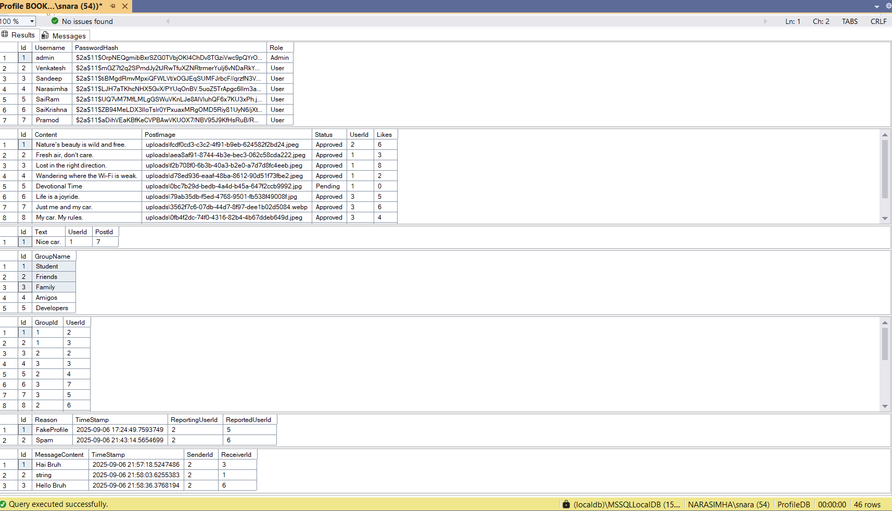

**ERD (Entity Relationship Diagram):**

* Boxes: Users, Profiles, Posts, Comments, Groups, Messages, Reports.
* Connectors: Show 1:1, 1:N, and M:N relationships.

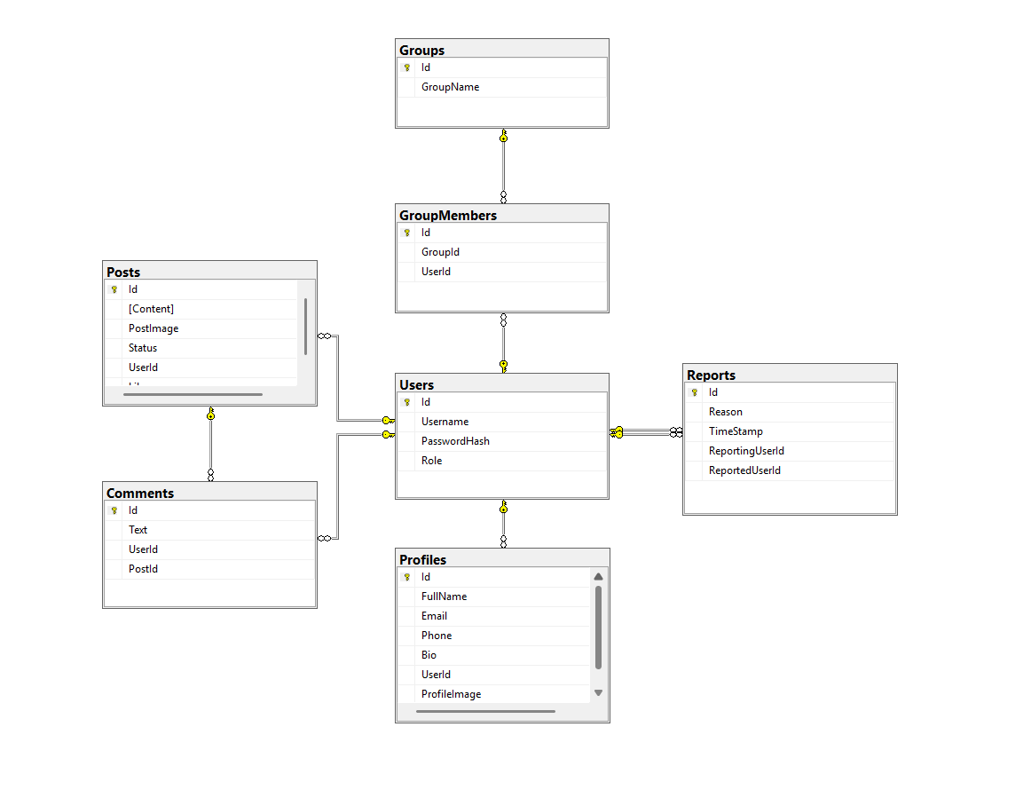**API ENDPOINTS**:

**AuthController:**

* **/api/auth/register (POST)**  
  Registers a new user by taking username, email, and password. Returns success message if registration is successful or an error if the email already exists or validation fails.
* **/api/auth/login (POST)**  
  Authenticates a user with email and password. Returns a JWT token for authorized access to protected routes.

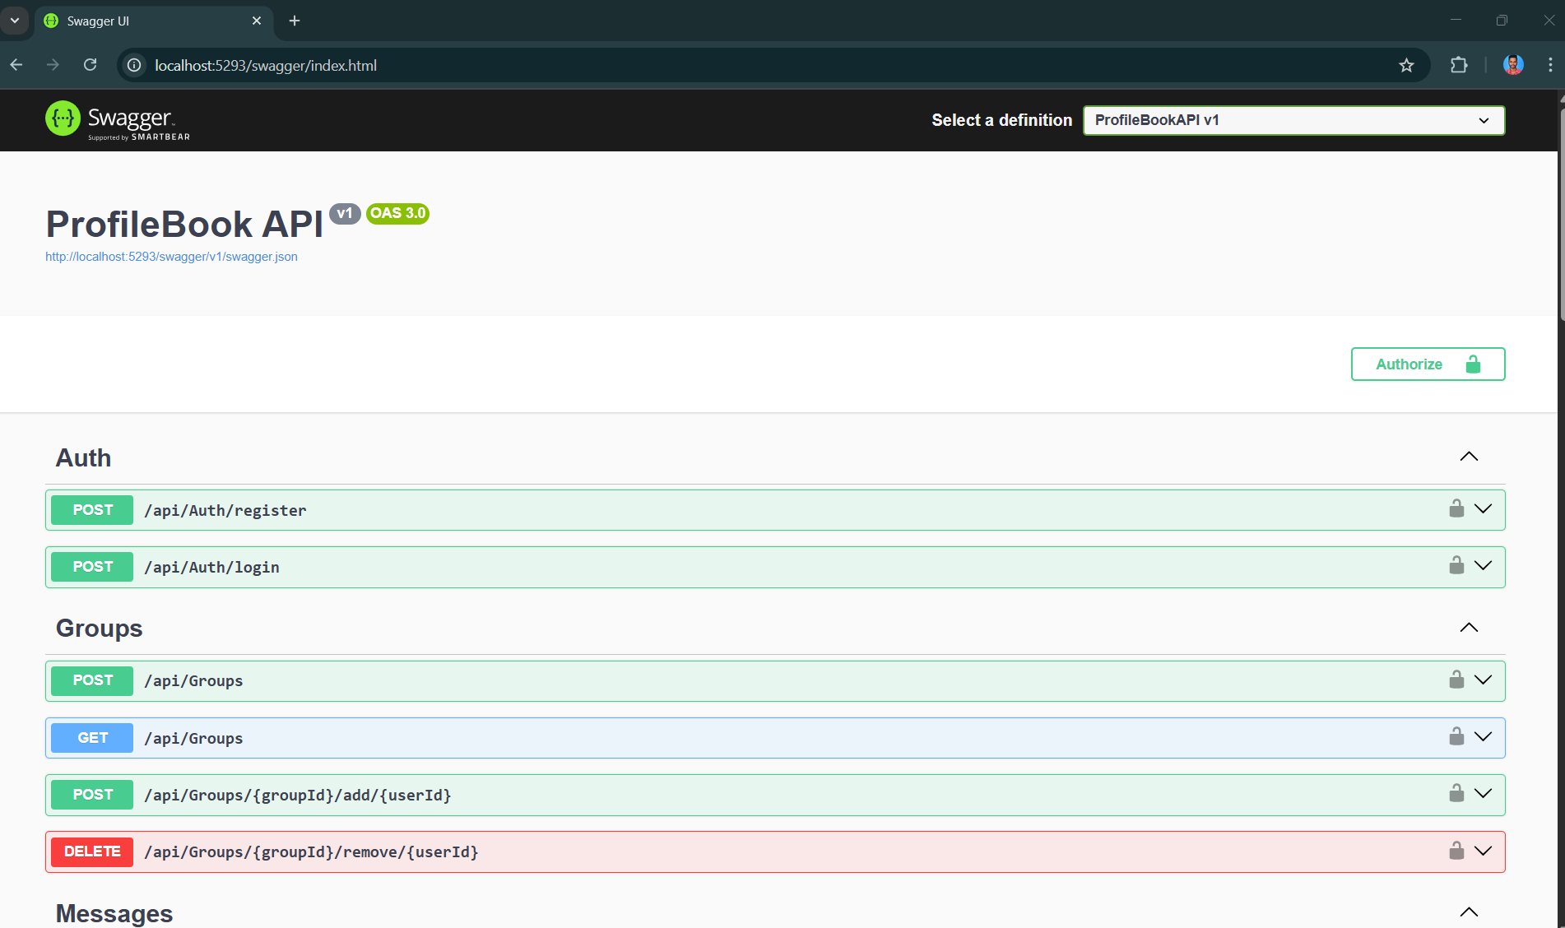

**UsersController**

* **/api/users (GET)**  
  Retrieves a list of all registered users. Useful for admin or listing users in the app.
* **/api/users/{id} (GET)**  
  Retrieves details of a specific user by their ID.
* **/api/users/{id} (PUT)**  
  Updates user information like username or email. Requires authentication.
* **/api/users/{id} (DELETE)**  
  Deletes a user from the system. Usually restricted to admin users.

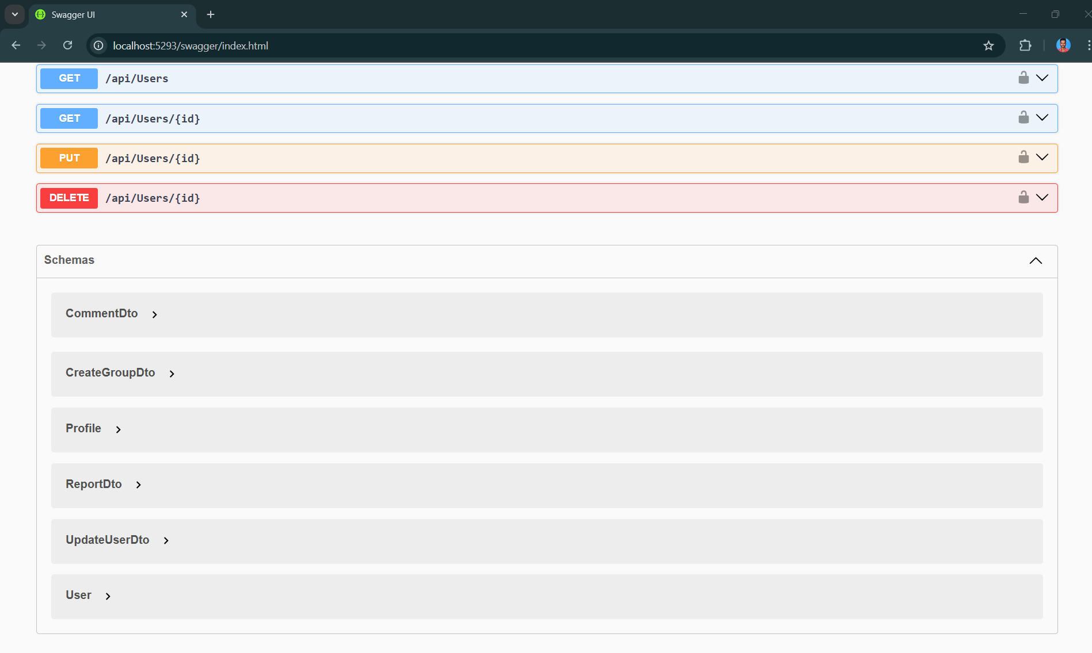

**MessagesController**

* **/api/Messages/{receiverId} (POST)**  
  Sends a message to a specific user identified by receiverId. Accepts the message content in the request body.
* **/api/Messages/{otherUserId} (GET)**  
  Fetches all messages between the current user and another user identified by otherUserId.
* **/api/Messages/to/{username} (POST)**  
  Sends a message to a user identified by their username. Accepts message content in the request body.
* **/api/Messages/with/{username} (GET)**  
  Fetches all messages exchanged with a specific user identified by username.

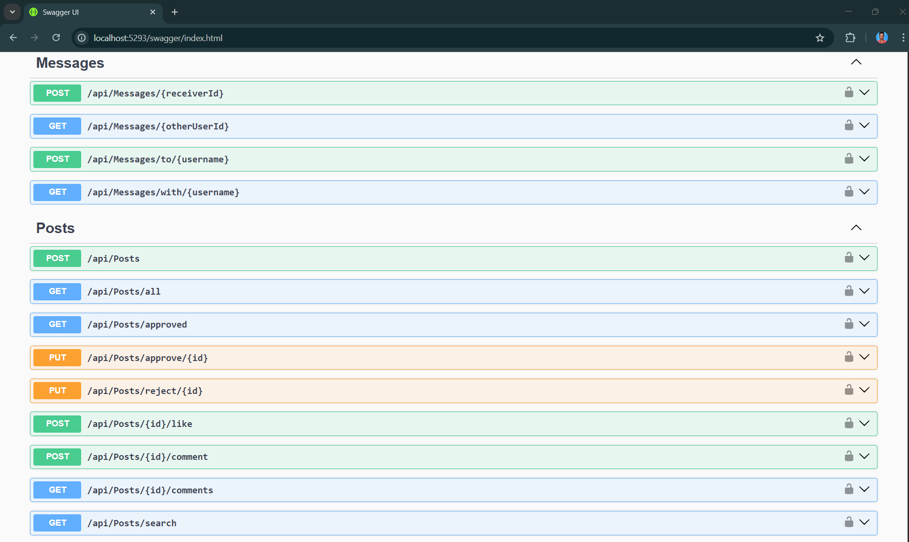

**PostsController**

* **/api/Posts (POST)**  
  Creates a new post. Accepts post data (title, content, etc.) in the request body.
* **/api/Posts/all (GET)**  
  Fetches all posts in the system, including both approved and pending posts.
* **/api/Posts/approved (GET)**  
  Fetches only approved posts for public display.
* **/api/Posts/approve/{id} (PUT)**  
  Approves a post by its ID. Usually restricted to admin users.
* **/api/Posts/reject/{id} (PUT)**  
  Rejects a post by its ID. Usually restricted to admin users.
* **/api/Posts/{id}/like (POST)**  
  Likes a specific post by its ID and updates the like count.
* **/api/Posts/{id}/comment (POST)**  
  Adds a comment to a specific post. Accepts comment text in the request body.
* **/api/Posts/{id}/comments (GET)**  
  Fetches all comments for a specific post.
* **/api/Posts/search (GET)**  
  Searches posts by keyword. Accepts query parameters like ?q=keyword.



**GroupsController**

* **/api/Groups (POST)**  
  Creates a new group. Accepts group details (like name and description) in the request body.
* **/api/Groups (GET)**  
  Fetches all groups in the system.
* **/api/Groups/{groupId}/add/{userId} (POST)**  
  Adds a specific user to a group. groupId identifies the group, and userId identifies the user to add.
* **/api/Groups/{groupId}/remove/{userId} (DELETE)**  
  Removes a specific user from a group. groupId identifies the group, and userId identifies the user to remove.



**ReportsController**

* **/api/Reports/{reportedUserId} (POST)**  
  Reports a specific user. Accepts the reason for reporting in the request body.
* **/api/Reports (GET)**  
  Fetches all reports. Usually restricted to admin users.

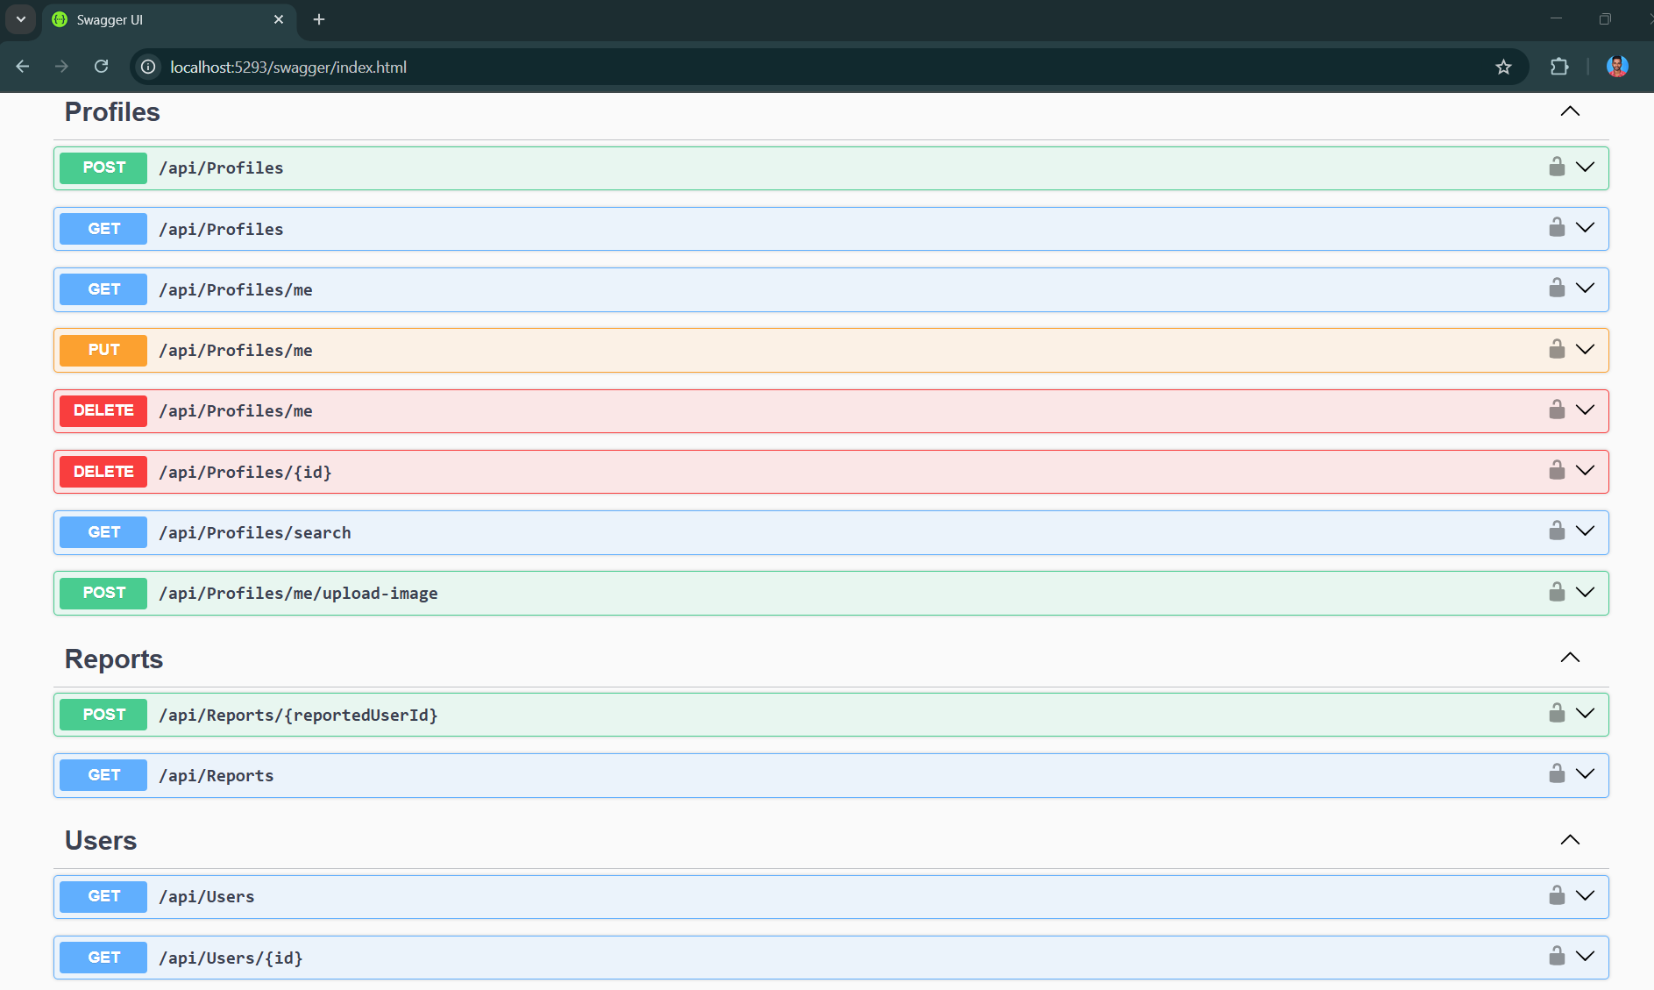

**ProfilesController**

* **/api/Profiles (POST)**  
  Creates a new profile. Accepts profile details (like bio, avatar, etc.) in the request body.
* **/api/Profiles (GET)**  
  Fetches all user profiles in the system.
* **/api/Profiles/me (GET)**  
  Fetches the profile of the currently logged-in user.
* **/api/Profiles/me (PUT)**  
  Updates the current user's profile. Accepts updated profile details in the request body.
* **/api/Profiles/me (DELETE)**  
  Deletes the current user's profile.
* **/api/Profiles/{id} (GET)**  
  Fetches the profile of a specific user by their ID.
* **/api/Profiles/search (GET)**  
  Searches profiles by keyword (like name or bio). Accepts query parameters.
* **/api/Profiles/me/upload-image (POST)**  
  Uploads or updates the profile image for the current user. Accepts an image file in the request body.



# Demo Plan & Screenshots:

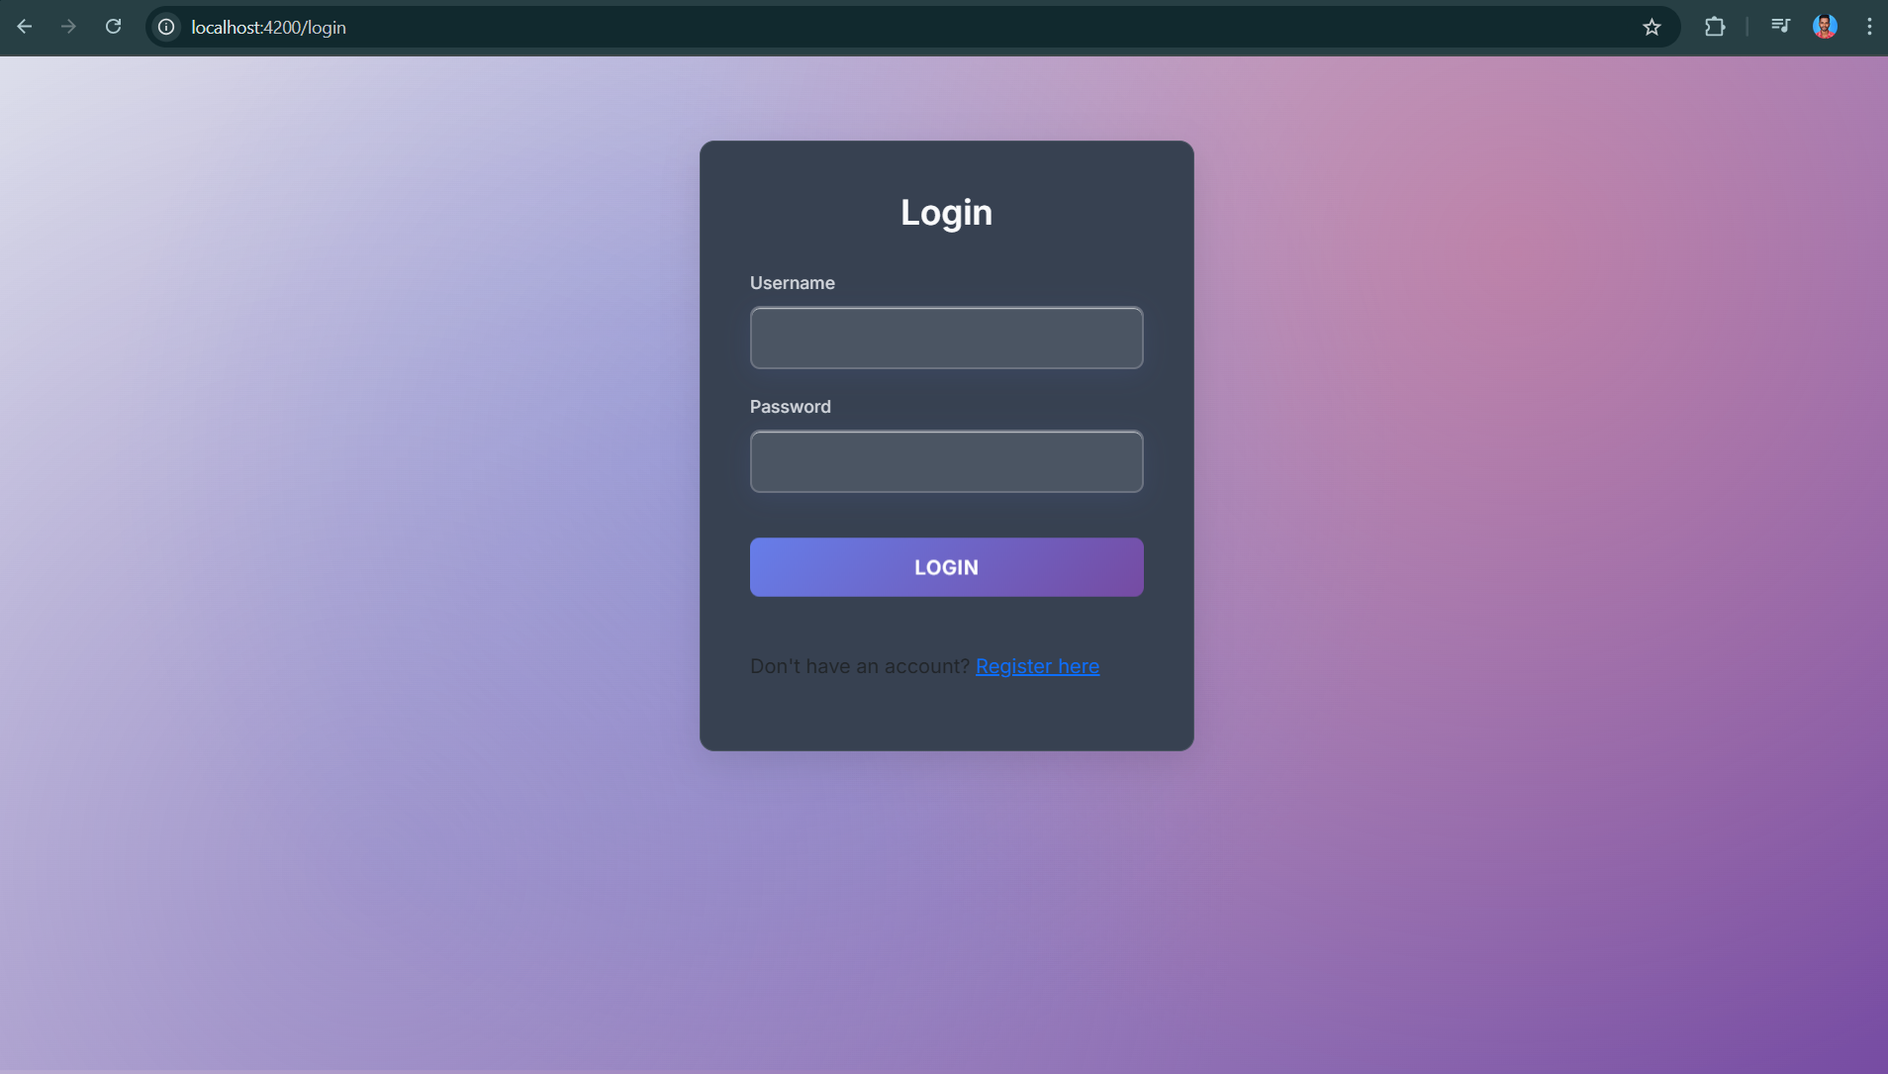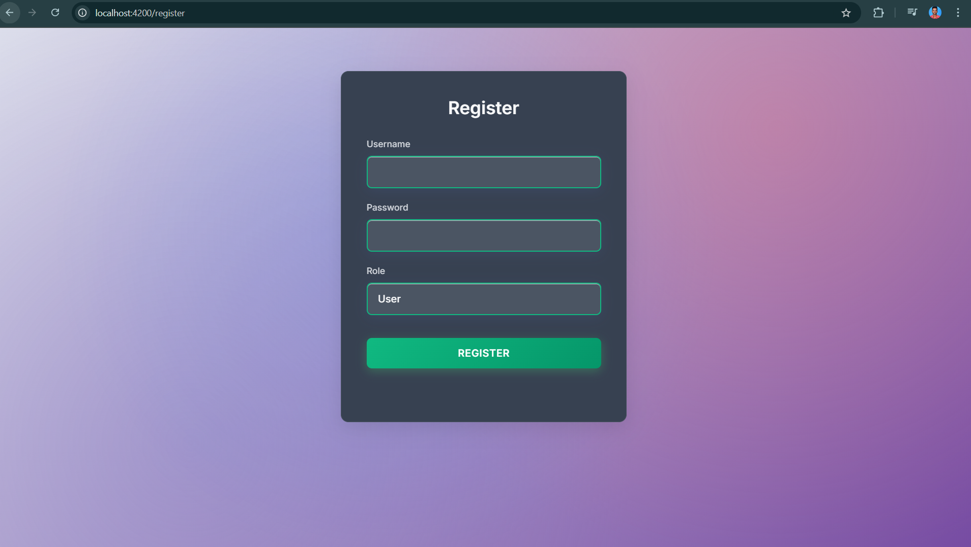**Login: Register:**

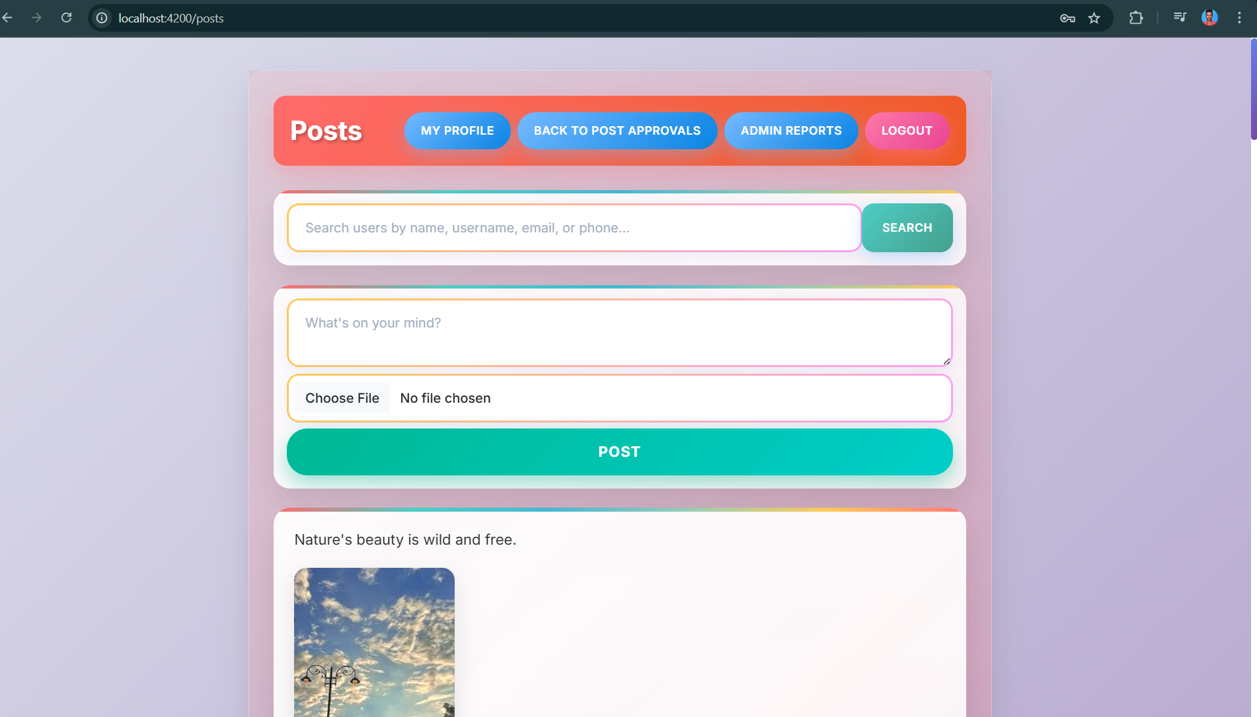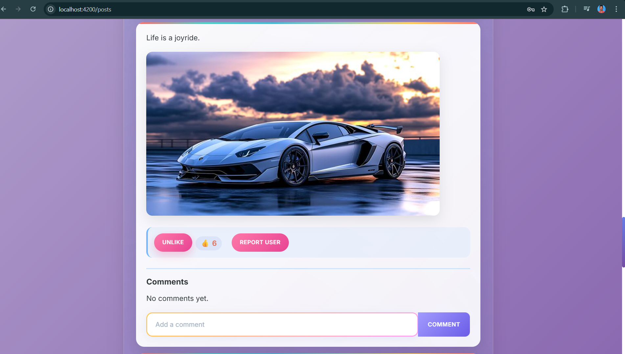**Posts:**

**Edit Profile:**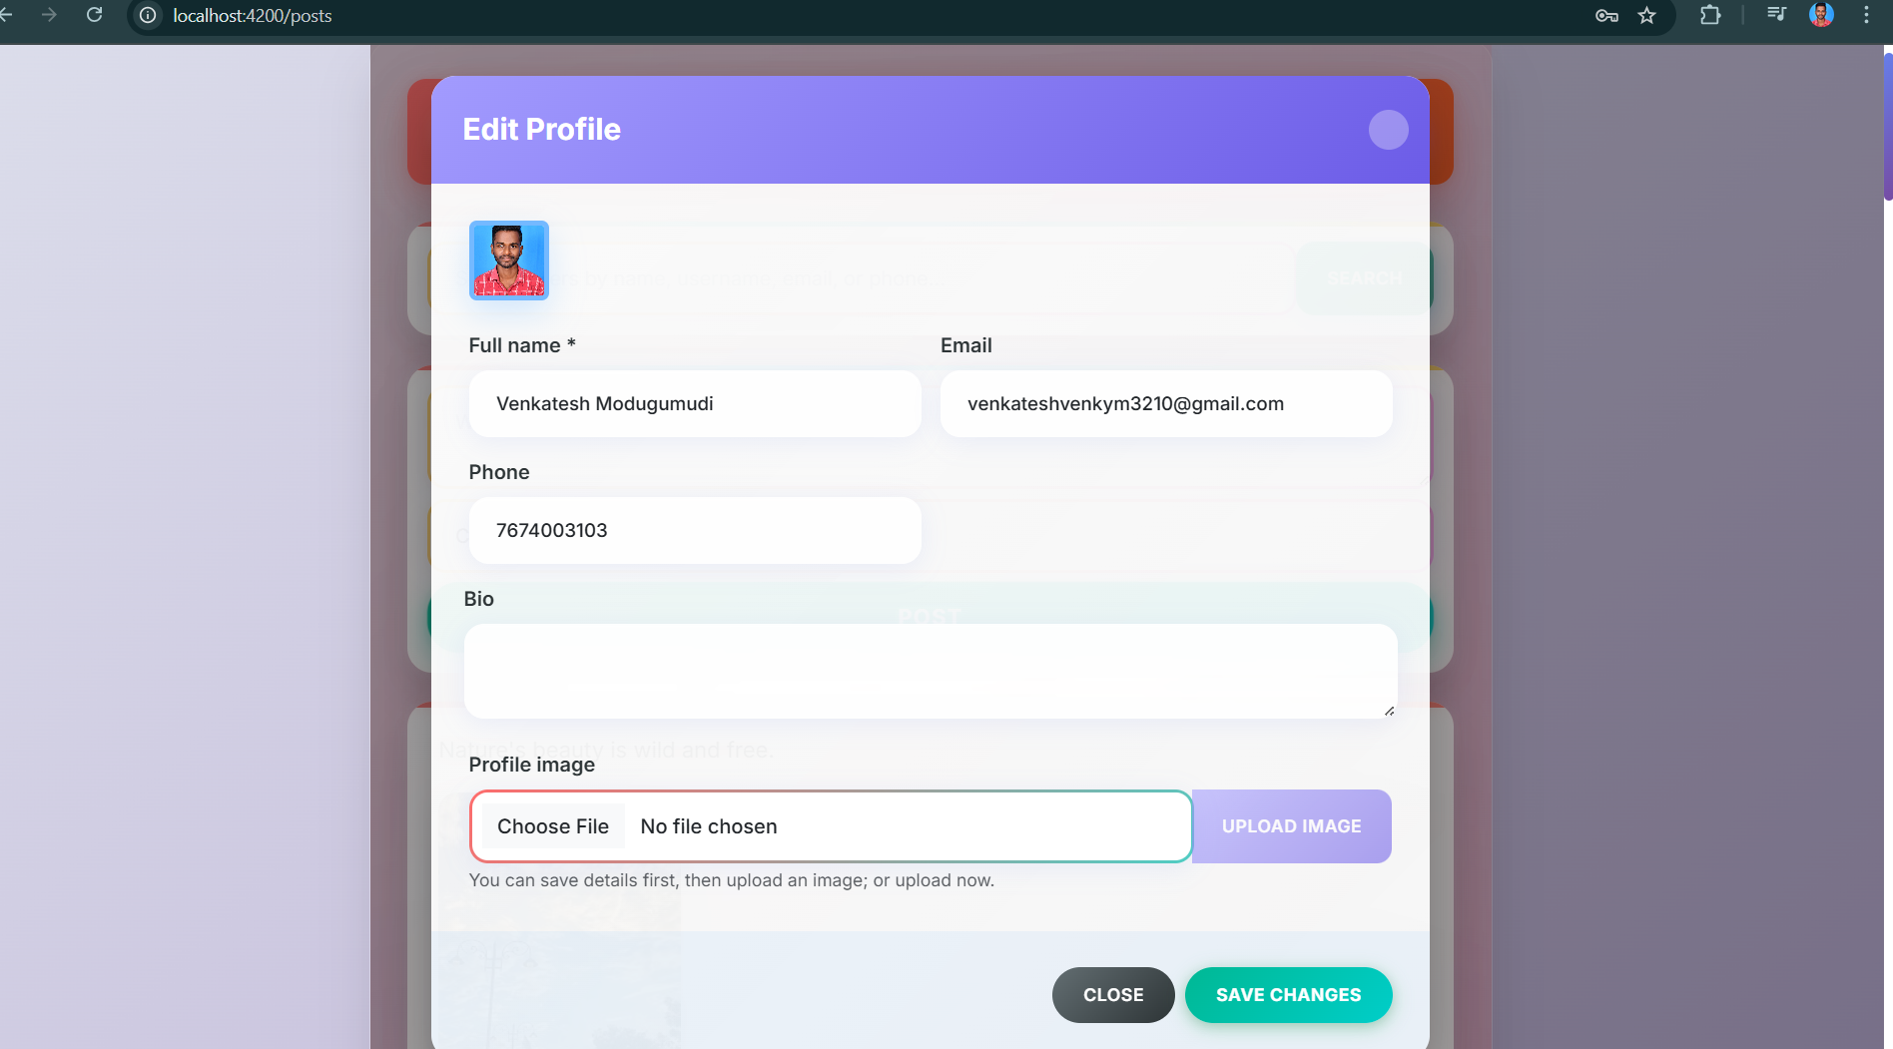

**Search User:**

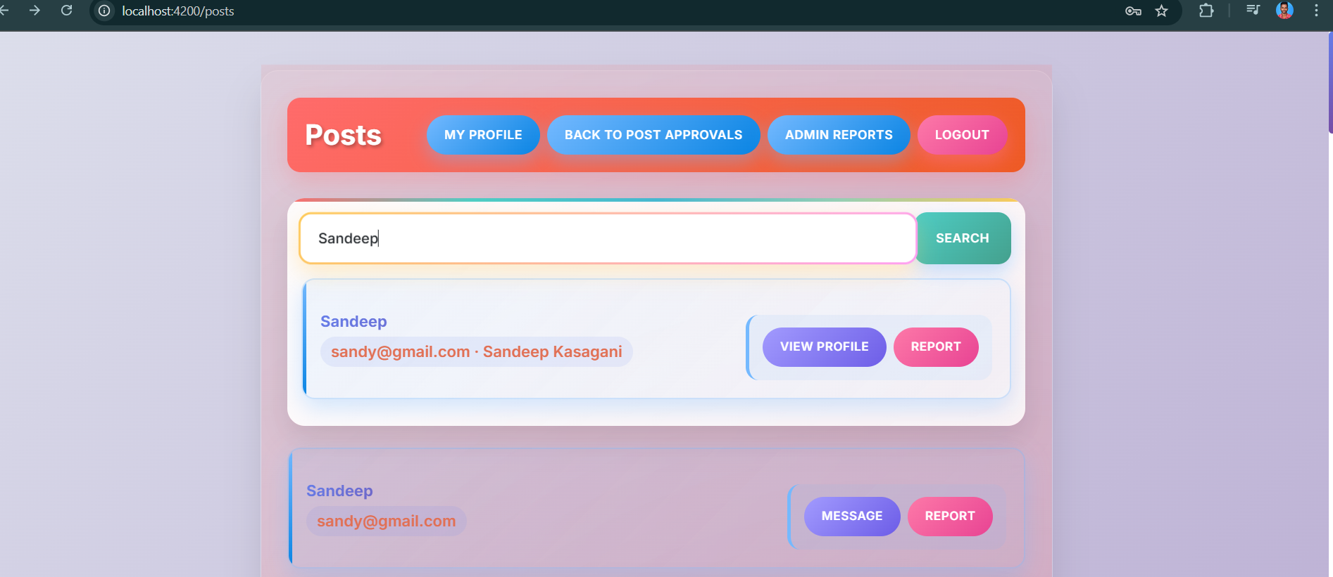

**Admin Approve Posts:**

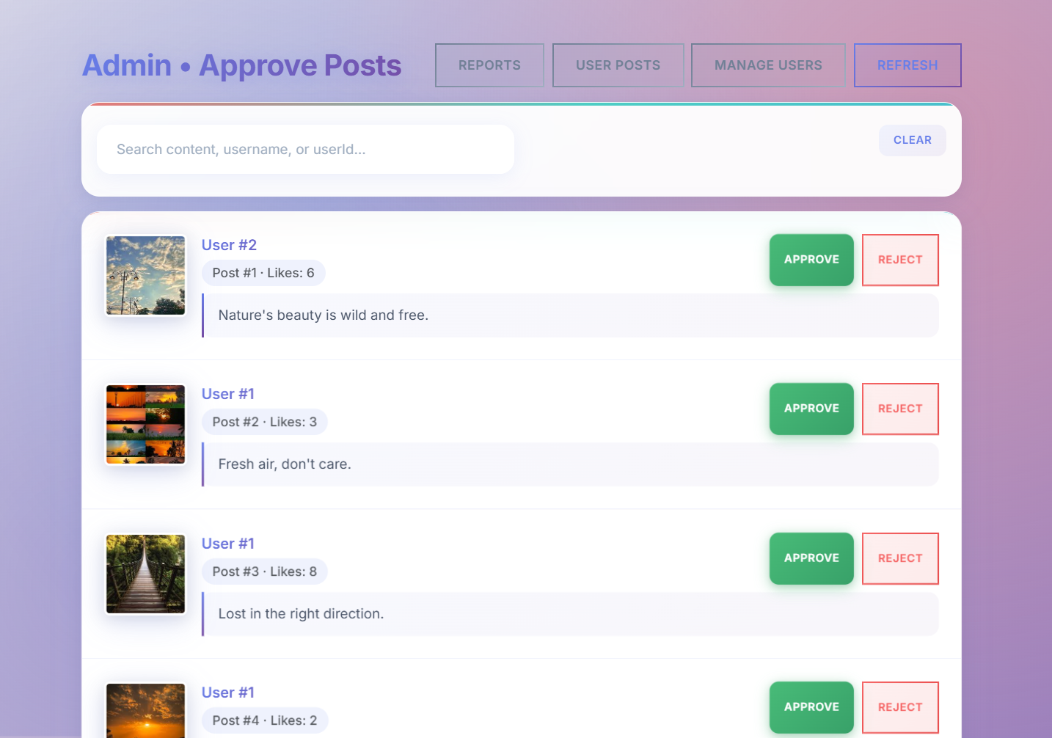

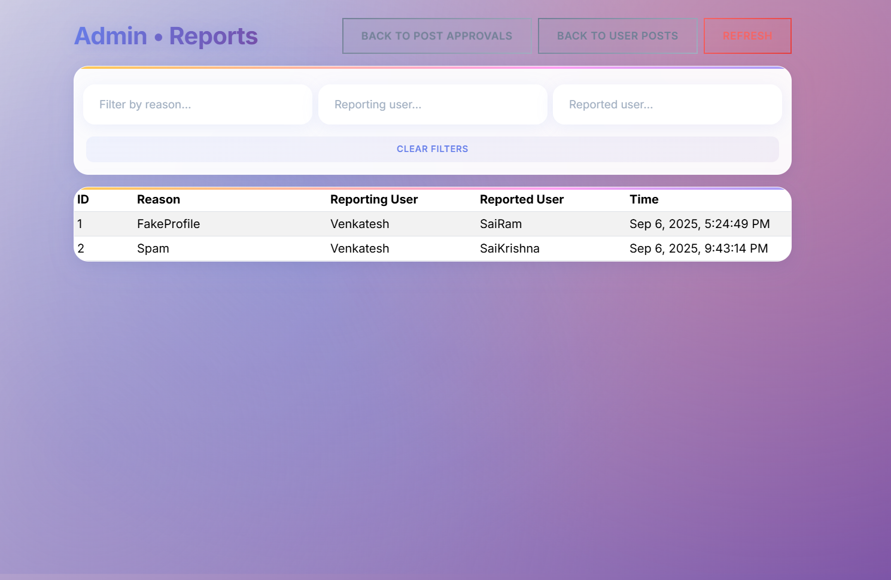**Admin Report:**

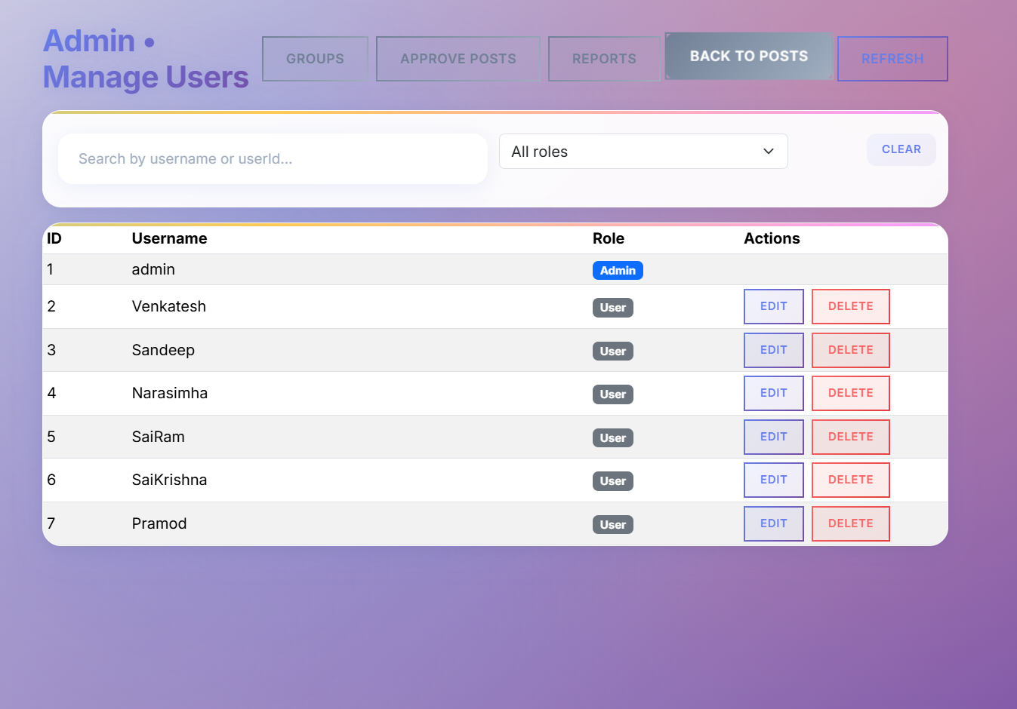**Admin Manage Users:**

**Admin Make Groups For Users:**

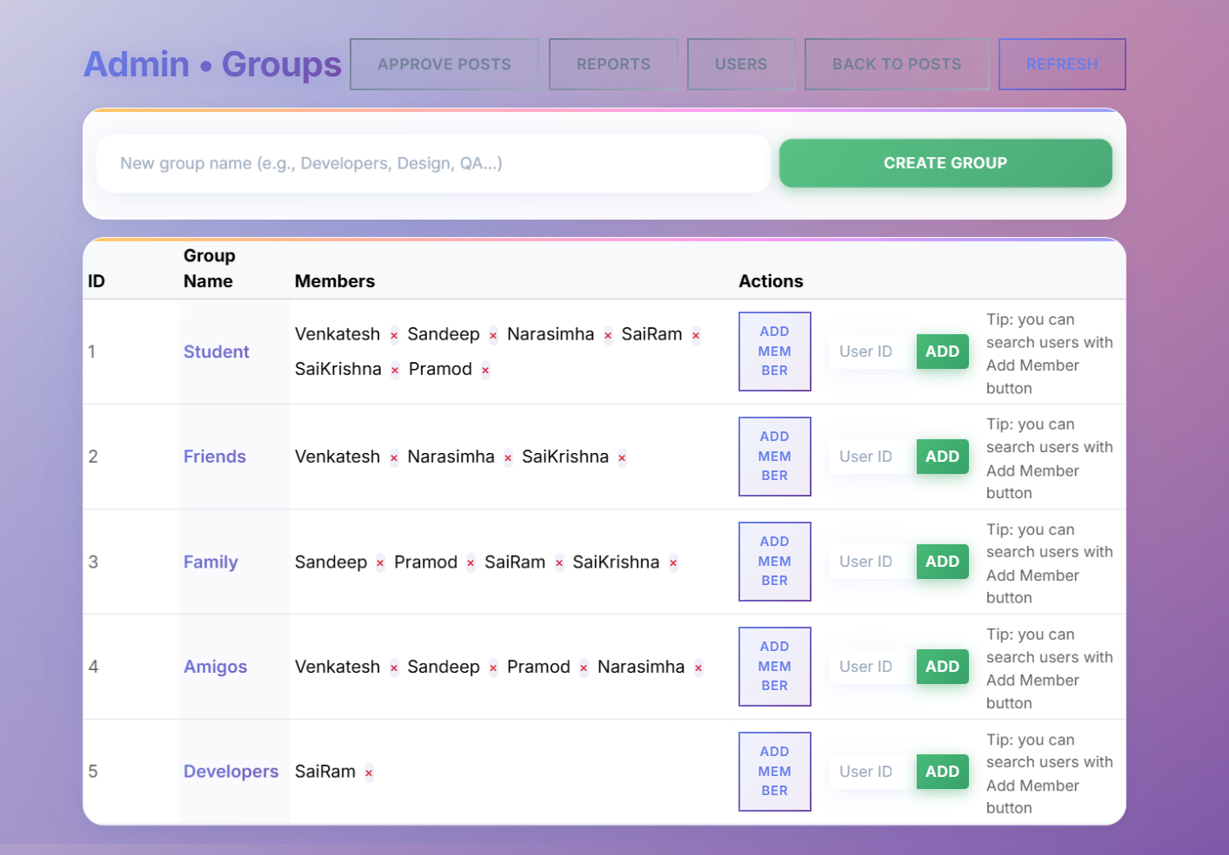

### Testing & Security

* **Manual Testing**
  + Each API endpoint was tested using **Postman** or **Swagger UI** to ensure correct functionality.
  + Inputs such as valid/invalid data, missing fields, and edge cases were verified.
  + Responses, status codes, and error messages were checked for accuracy.
* **Unit Testing**
  + Key controller methods (e.g., Posts, Auth, Users) were covered with **unit tests** using frameworks like **xUnit** or **NUnit**.
  + Business logic and data access layers were tested separately to ensure correctness.

* **Integration Testing**
  + Tested end-to-end flows such as **user registration → login → create post → comment** to ensure multiple endpoints work together.
  + Verified database updates reflect accurately after API calls.

### Security

* **Authentication & Authorization:** Protected endpoints use **JWT tokens**; only authorized users can access restricted routes.
* **Role-Based Access:** Admins can manage posts, users, and reports; regular users have limited access.
* **Input Validation:** API requests are validated to prevent invalid or malicious data.
* **Data Protection:** Passwords are **hashed**, and sensitive data is never exposed.
* **Common Attack Prevention:** Measures against **SQL Injection** and **XSS** are implemented.

# 

# Conclusion & Future Work

**Conclusion**

The project successfully implements a **full-featured social interaction platform** with user authentication, posts, comments, groups, messaging, profiles, and reporting functionality. All API endpoints are functional and secured with **JWT authentication** and **role-based access control**. The system allows smooth interaction between users while ensuring data integrity and security.

**Future Work**

* **Enhanced Security:** Implement features like **two-factor authentication** and more robust input sanitization.
* **Real-Time Features:** Add **real-time messaging and notifications** using WebSockets or SignalR.
* **Advanced Search & Filters:** Improve search functionality with filters for posts, users, and groups.
* **Admin Dashboard:** Develop a **comprehensive dashboard** for monitoring reports, user activity, and content approval.
* **Mobile Support:** Build a **mobile-friendly version** or mobile app for better accessibility.